Dense Passage Retrieval for Open-Domain Question Answering

Almost all NLP applications were heavily utilizing TF-IDF sparse vector algorithms for text-based answers but this algorithm required heavy training on large amount of corpus or dataset. To overcome from this issue author of this paper employing dense based word embedding technique to answer questions. This dense based word embedding can be generate for any text without requiring any further training.
Converting any text into numeric vector is called as Dense embedding and author utilizing BERT based algorithm to convert text into numeric dense vector. This vector will be processed through Inner DOT product to measure similarity between questions vector and to predict accurate answers. Propose algorithm required no heavy training and can compete with any advance answering tool like BM2.5.
In propose paper author compare Dense Passage Retrieval technique with many other algorithms. Each algorithm performance is evaluated using Accuracy and tested on many datasets.
Extension Concept
The proposed model extends traditional question–answer retrieval systems by leveraging advanced Dense Passage Retrieval (DPR) techniques. It integrates multiple key components to enhance semantic understanding and retrieval accuracy. The Embedding Model used is E5-Large-V2 (Sentence Transformer), a transformer-based bi-encoder model that converts questions and answers into dense vector embeddings capturing rich contextual meaning. The Similarity Function employed is Cosine Similarity, which measures the semantic closeness between two embeddings. Altogether, the system operates within the Dense Passage Retrieval (DPR) framework, enabling it to retrieve relevant answers based on semantic relationships rather than surface-level keyword matching, thus significantly improving the model’s retrieval precision and overall accuracy.

Training algorithm on all datasets may consume more time so we are using WEB-QUESTION dataset available on KAGGLE repository. Other datasets size is above 5 GB whose training is not possible on normal laptops.
In below screen showing dataset samples
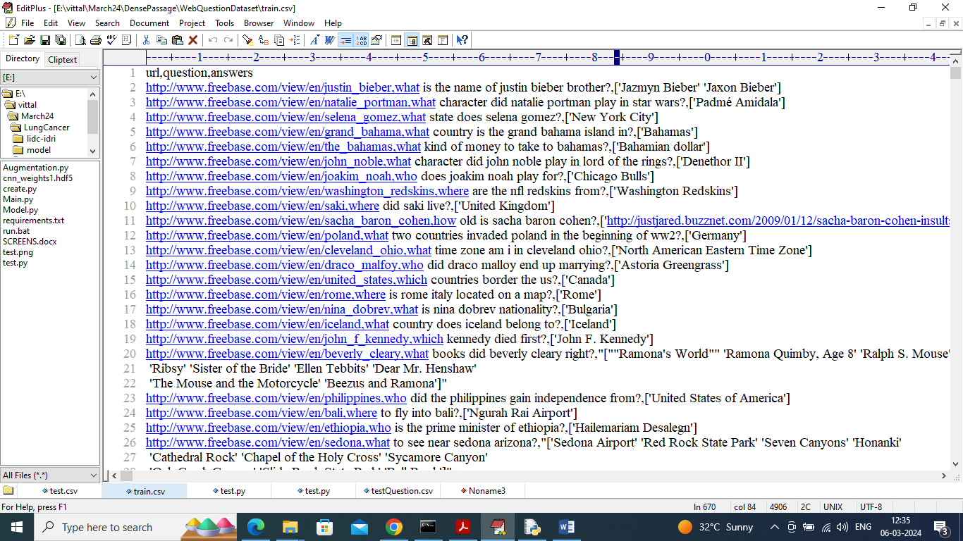
In above dataset we have questions and answers and its available for both training and testing. We will use training data to train DPR model and then used TEST data for prediction and to calculate accuracy.

SCREEN SHOTS
To run project double, click on ‘run.bat’ file to get below screen
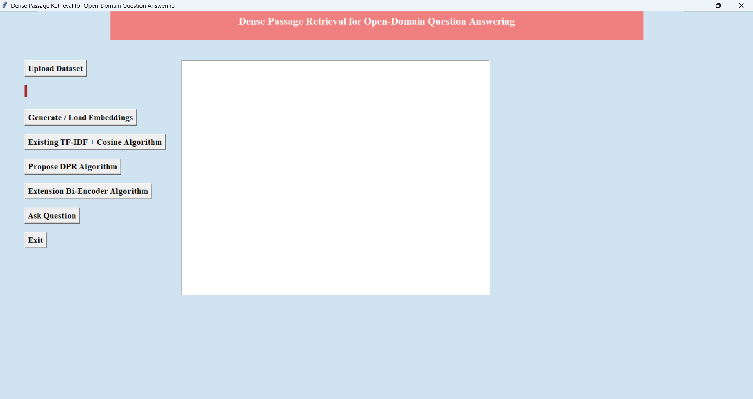
In above results click on ‘Upload Dataset’ button and upload dataset
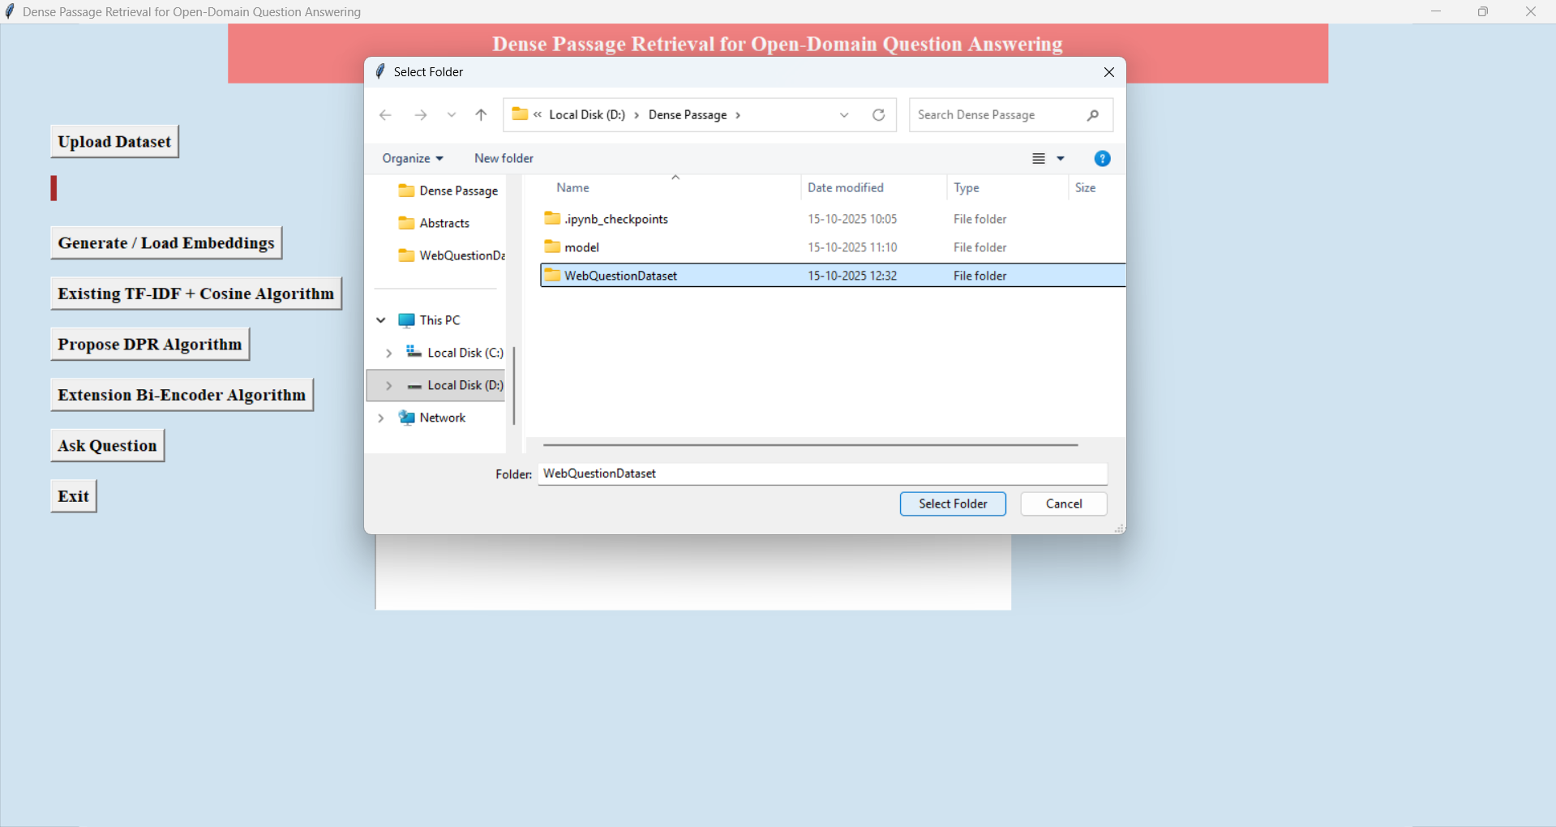
In above results selecting and uploading ‘WebQuestionDataset’ file and then click on ‘Select Folder’ button to get below results and to load dataset
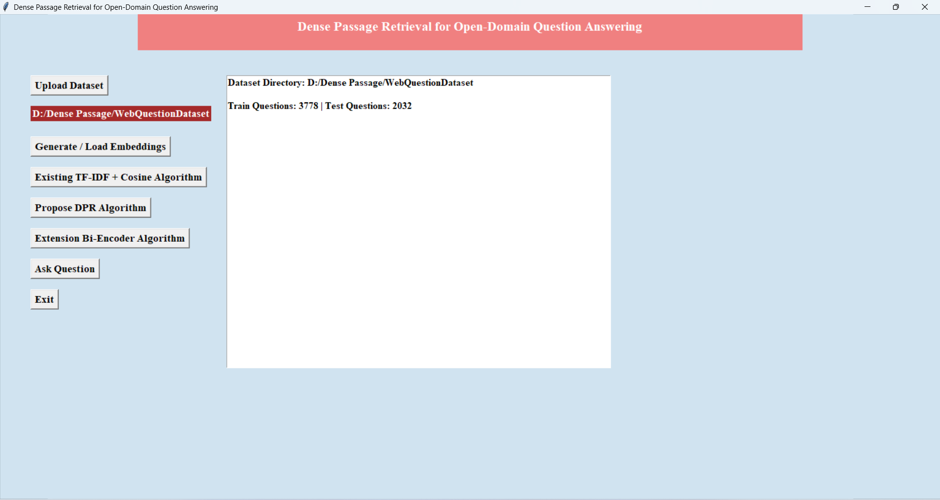
In above results we can see the dataset is uploaded and Select Generate/Load Embeddings Button
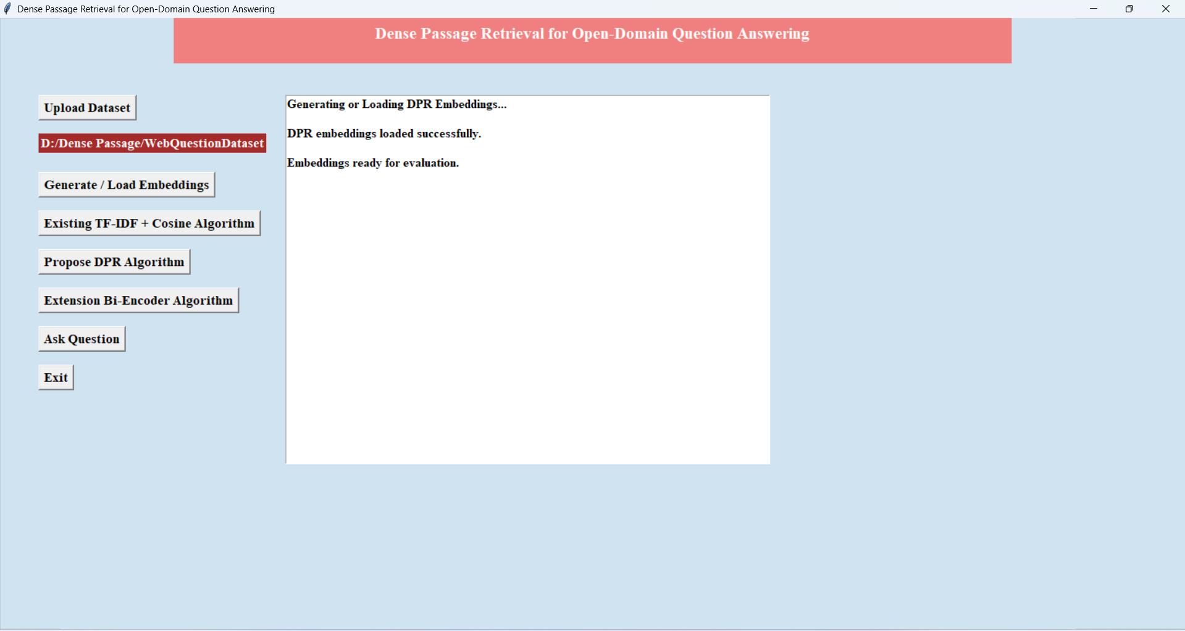
In above results we can see the Embedding is ready for evaluation and Select “Existing TF-IDF + Cosine Algorithm” Button

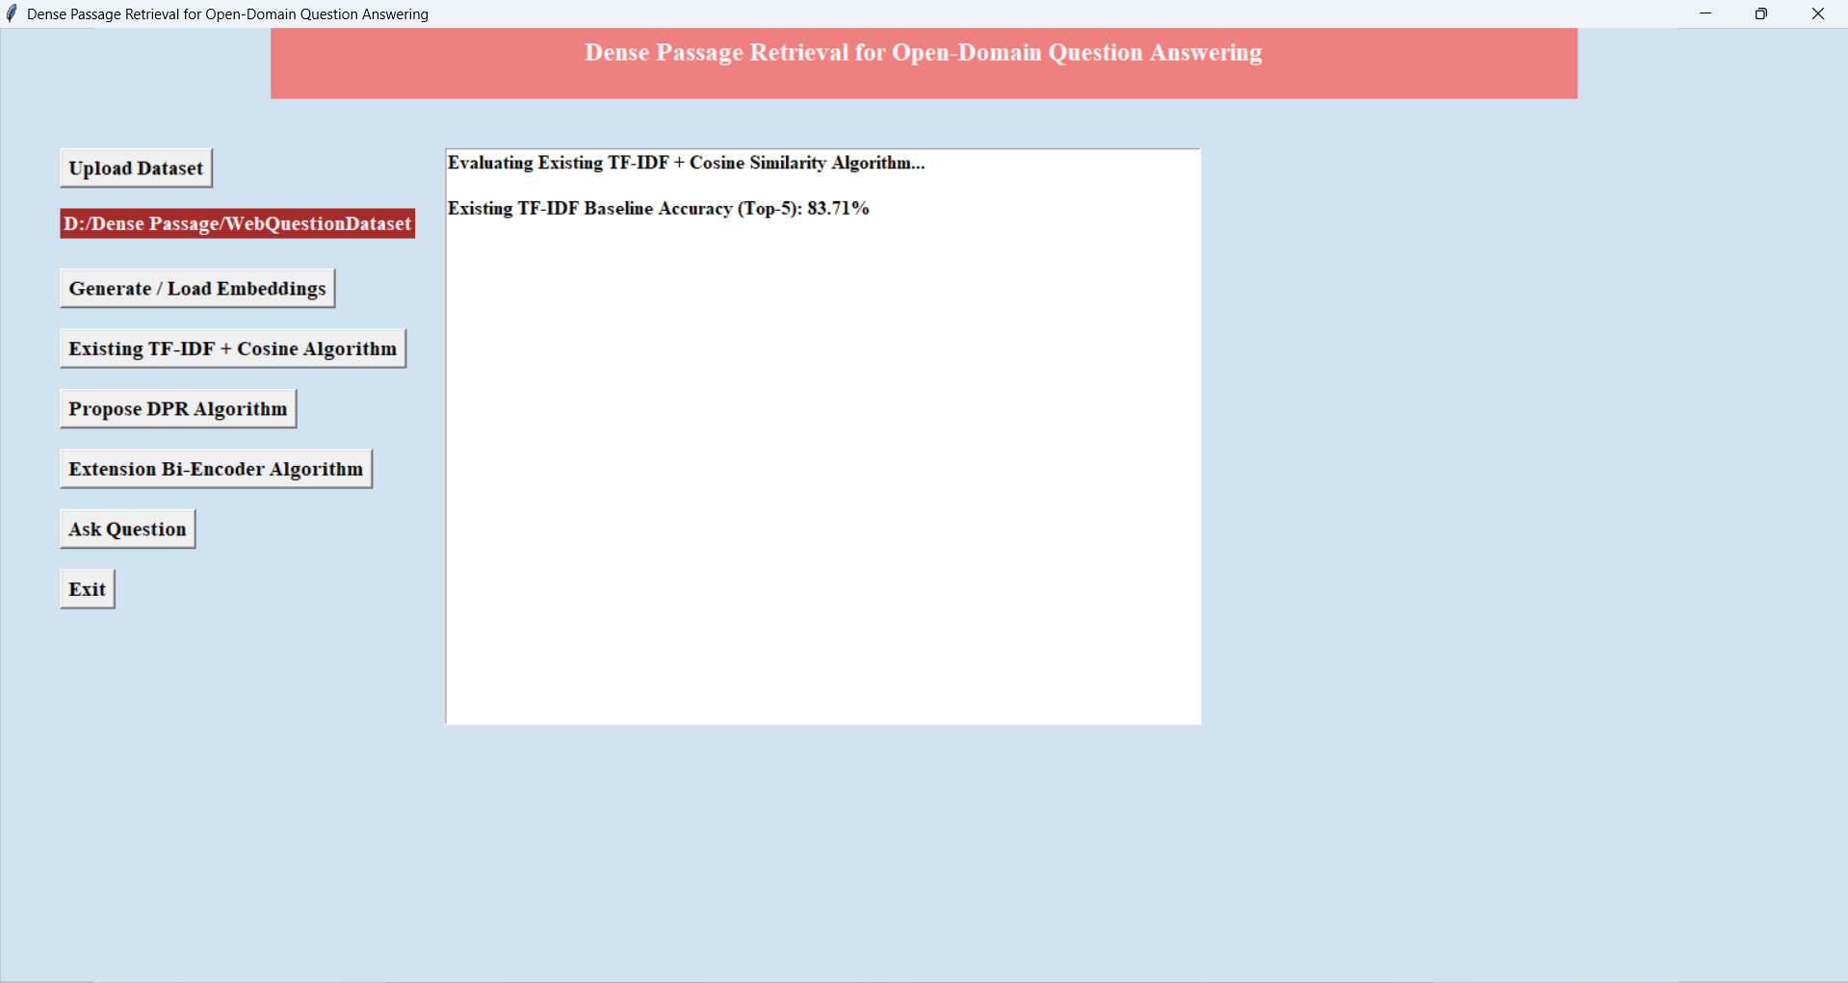
In above results we can see the Accuracy of TF-IDF + Cosine Algorithm is 83 % and Select “Propose DPR Algorithm” Button
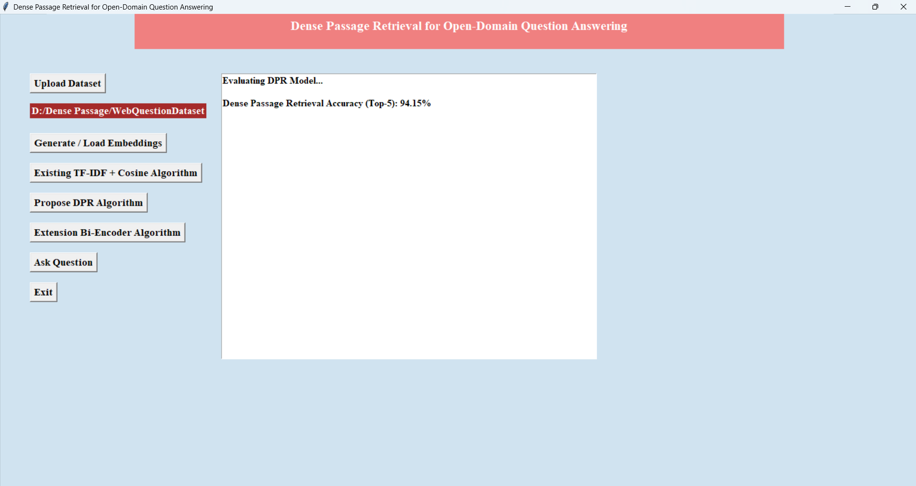
In above results we can see the Accuracy of DPR Algorithm is 94 % and now Select “Extension Bi-Encoder Algorithm” Button

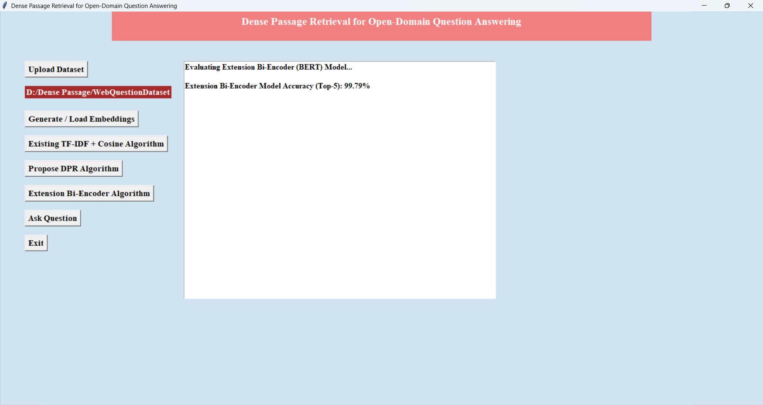
In above results we can see the Accuracy of Bi-Encoder Algorithm is 99 % and Now Select “Ask Questions” Button
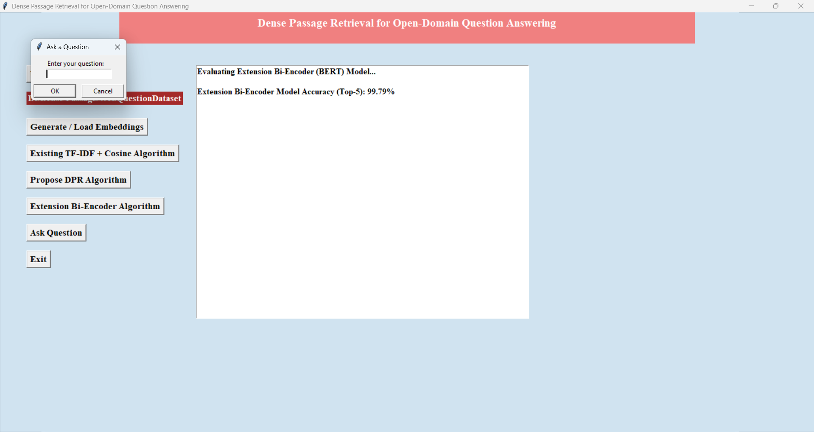
In above results importing some test question samples and then predicting answers using DPR model and it is showing the predicted answers with questions

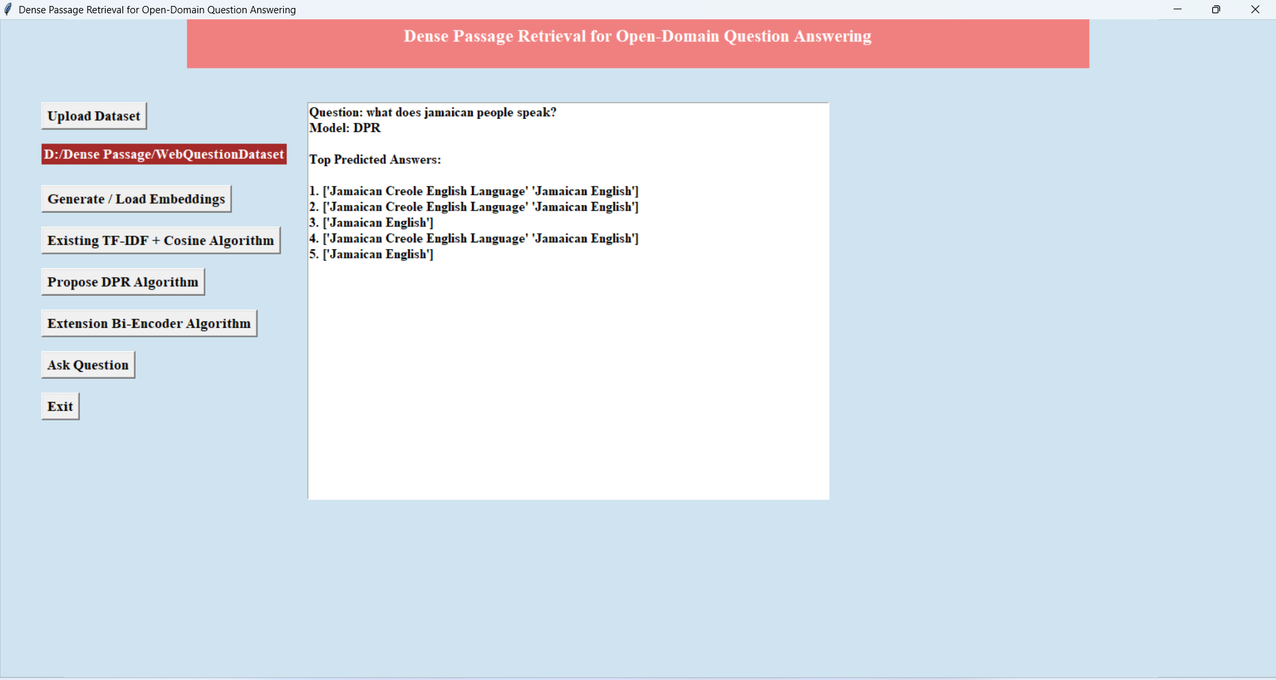
In above results text question was ‘What does Jamaican people speak’ below it is showing the Predicted Answers Same like Above All Prediction Will Work
